UNIVERSITY INSTITUTE OF COMPUTING

PROJECT REPORT
ON SIMPLE CALCULATOR

Program Name: BCA
Subject Name/Code: Data Structures (24CAP-152)

Submitted by: Submitted to:
Name: Kamohelo Maleke Name: Mehak Bhatia
UID: 24BCA10196 Designation: Assistant Professor
Section: BCA – 4“A”
Group: 4

Table of Contents
Introduction 3
Objective 3
Algorithm and Implementation 3
Code Walkthrough 4
Output 6
Key Concepts 6
Real-World Utility 7
Educational Context 7
Strength 7
Limitations 8
Conclusion 8

Introduction

This report examines a program designed to handle forex exchange data, showcasing the application of structures in the C programming language. Forex (foreign exchange) trading involves the exchange of currency pairs, and the program models a simple system to store and manage forex trading data. The program demonstrates the use of a struct data type for representing forex exchange data, dynamic memory allocation for data storage, and functions for operations like creating, printing, and freeing forex data.

Objective

- The primary objective of this program is to design a data structure capable of storing and manipulating forex exchange details such as currency pairs, bid prices, ask prices, and timestamps. This program showcases the following:
- Effective use of struct for custom data representation.
- Dynamic memory allocation using malloc and free.
- Functions to encapsulate and reuse data operations.

Algorithm and Implementation

- Defining the Forex Data Structure
- Currency Pair: Stores a 6-character currency pair code, e.g., "EURUSD".
- Bid Price: Stores the bid price as a double.
- Ask Price: Stores the ask price as a double.
- Last Price: Stores the last traded price as a double.
- Timestamp: Stores a 19-character timestamp, e.g., "2025-04-11 10:00:00".

- Creating Forex Data Instances
- A function, createForexData, is implemented to dynamically allocate memory for a new Forex Data instance and initialize its fields.
- Inputs: Currency pair, bid price, ask price, last price, and timestamp.
- Outputs: A pointer to the initialized Forex Data instance.

- Printing Forex Data
- A function, printForexData, is implemented to display the contents of a Forex Data instance in a user-friendly format.

- Freeing Allocated Memory
- A function, freeForexData, is implemented to deallocate the memory associated with a Forex Data instance to prevent memory leaks.

- Example Usage
- The main function demonstrates how to create, use, and clean up a Forex Data instance. The example uses data for the EUR/USD currency pair with realistic values.

Code Walkthrough

#include <stdio.h>
#include <stdlib.h>
#include <string.h>

// Define a structure for holding Forex exchange data
typedef struct {
char currencyPair[7]; // e.g., "EURUSD"
double bidPrice;
double askPrice;
double lastPrice;
char timestamp[20]; // e.g., "2025-04-11 10:00:00"
} ForexData;

// Function to create a new ForexData instance
ForexData* createForexData(const char* pair, double bid, double ask, double last, const char* time) {
ForexData* newData = (ForexData*)malloc(sizeof(ForexData));
if (newData == NULL) {
fprintf(stderr, "Memory allocation failed\n");
exit(1);
}
strncpy(newData->currencyPair, pair, sizeof(newData->currencyPair) - 1);
newData->currencyPair[sizeof(newData->currencyPair) - 1] = '\0';
newData->bidPrice = bid;
newData->askPrice = ask;
newData->lastPrice = last;
strncpy(newData->timestamp, time, sizeof(newData->timestamp) - 1);
newData->timestamp[sizeof(newData->timestamp) - 1] = '\0';
return newData;
}

// Function to print ForexData
void printForexData(const ForexData* data) {
if (data != NULL) {
printf("Currency Pair: %s\n", data->currencyPair);
printf("Bid Price: %.5f\n", data->bidPrice);
printf("Ask Price: %.5f\n", data->askPrice);
printf("Last Price: %.5f\n", data->lastPrice);
printf("Timestamp: %s\n", data->timestamp);
}
}

// Function to free ForexData
void freeForexData(ForexData* data) {
if (data != NULL) {
free(data);
}
}

int main() {
// Example usage
ForexData* data = createForexData("EURUSD", 1.12345, 1.12355, 1.12350, "2025-04-11 10:00:00");
printForexData(data);
freeForexData(data);
return 0;

Output
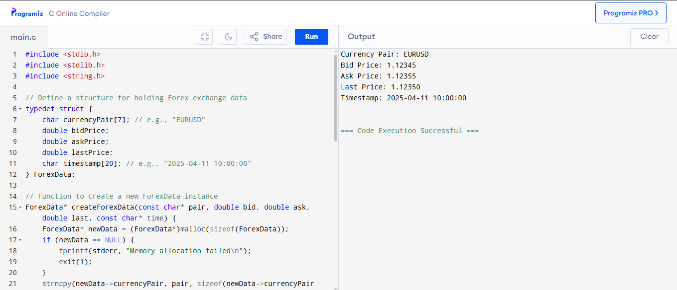

Key Concepts
- Data Structures:
- Struct: The program uses a structure to group related Forex market attributes into a single unit.
- Dynamic Memory Allocation:
- malloc: Allocates memory for new instances of Forex Data at runtime.
- Free: Releases the allocated memory to avoid memory leaks.
- Functions:
- Modularity: Functions like createForexData, printForexData, and freeForexData encapsulate specific tasks, enhancing code readability and reusability.

Real-World Utility
- This program can serve as the foundation for developing a forex trading application.
- It stores key metrics like bid and ask prices for currency pairs.
- Timestamp integration allows for tracking historical data.

Educational Context
- Demonstrates the use of structures for real-world problem-solving.
- Provides insights into dynamic memory allocation and basic data manipulation.
- Demonstrates the practical application of structures and dynamic memory allocation in C.
- Encourages a hands-on approach to learning modular programming and efficient memory management.
- Offers insights into how real-world financial data can be structured and processed.

Strength
- Scalability:
- The design allows for easy extension by adding more attributes or integrating external data sources.
- Modularity:
  - Each functionality is encapsulated in a separate function, making the code more maintainable and reusable.
- Practical Relevance:
  - Provides a realistic example of how to manage structured data in financial applications.

- Memory Efficiency:
  - Dynamic allocation ensures that memory is used only when required.

Limitations

- The program does not handle input validation (e.g., checking for invalid data).
- The Forex Data structure is static in terms of size, limiting its flexibility.

Conclusion

This program is an excellent example of applying data structures in C for practical problem-solving. It demonstrates how to design and manipulate custom data structures effectively while emphasizing clean coding practices, dynamic memory management, and modularity. This program provides an excellent demonstration of structuring and managing financial data using C. It highlights the use of dynamic memory allocation, modular programming, and encapsulation in a real-world context. While currently limited in scope, its design can be expanded to handle real-time data and more complex processing, making it a valuable tool for educational and practical applications in financial systems.

